**Cherry-Pick:**

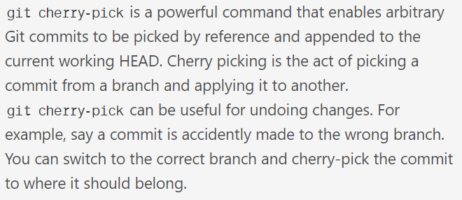

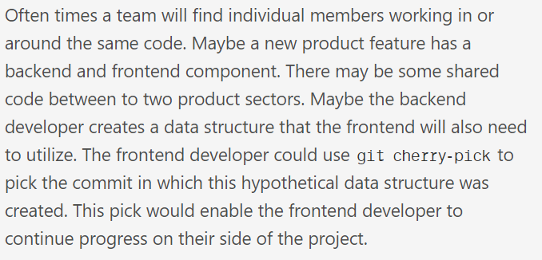

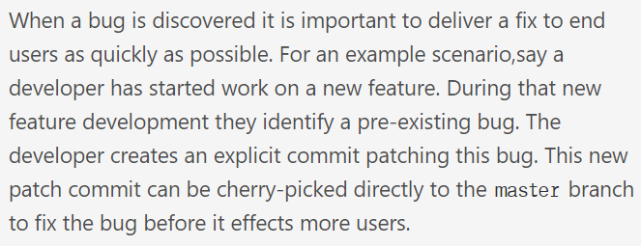

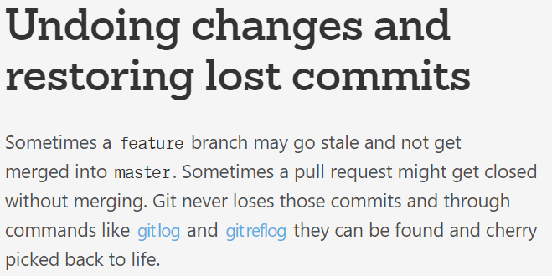

**Example:**

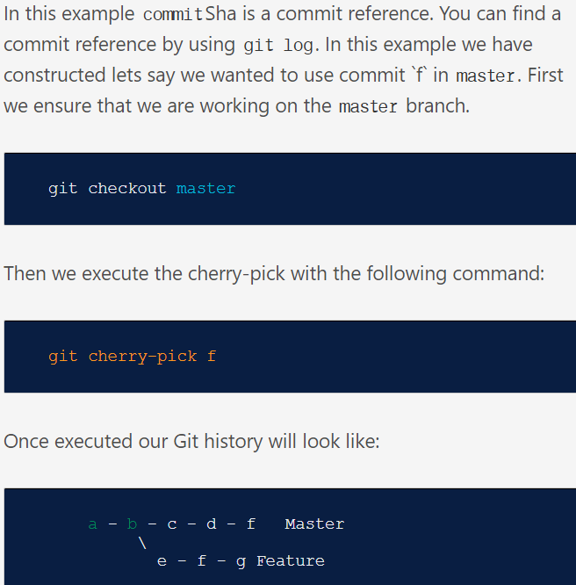

**Commands:**

If we want to merge a single commit instead of a whole branch, we can use cherry-pick command as below.

* **Git cherry-pick <commit ID> 🡪you need to run this command from destination branch**

If there are multiple commits, we can use the below command

* **Git cherry-pick <commit1> <commit2> <commit3>**

Let’s say with this command if commit1 got merged successfully and then commit2, we get conflicts. We can resolve them and do a fresh commit.

After this, we can still see the git status as “cherry-picking”. So we can use the below command so that git will process to the next commit ID

* **Git cherry-pick –continue**

Incase if we want to abort the process. We can use the below command

* **Git cherry-pick –abort**

Passing the -edit option will cause git to prompt for a commit message before applying the cherry-pick operation

* **-edit**

The --no-commit option will execute the cherry pick but instead of making a new commit it will move the contents of the target commit into the working directory of the current branch.

* **--no-commit**